AI-Based Smart Waste Segregation and Recycling Automation System

(Architecture Design Assignment)

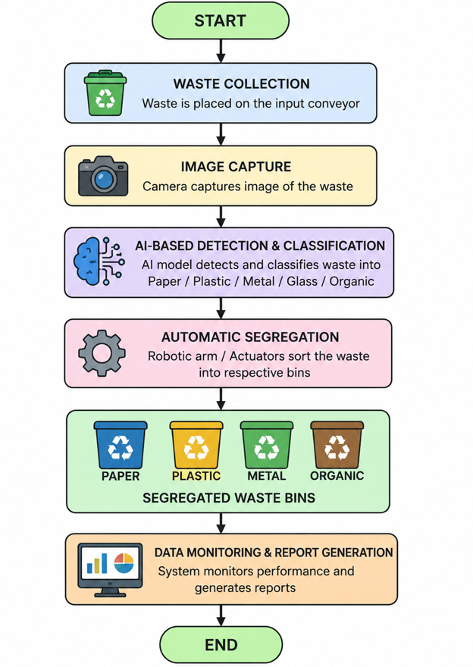

1. Analysis of System Requirements

1.1 Industry Context and Problem Overview
Efficient waste segregation is fundamental to sustainable waste management and recycling. Manual segregation at municipal waste processing facilities is labour-intensive, error-prone, and often results in recyclable materials being discarded into landfills. Advances in Artificial Intelligence, Computer Vision, Robotics, and the Internet of Things (IoT) now make it possible to automate waste identification and sorting, directly supporting circular-economy initiatives. The proposed system uses computer vision to classify waste, robotic actuators to physically sort it, and an analytics layer to monitor recycling performance and generate management reports, with the overall goal of improving recycling efficiency while reducing environmental pollution.

1.2 System Objectives
- Classify waste automatically using AI-based computer vision.
- Automate physical waste segregation using robotic sorting mechanisms.
- Continuously monitor recycling operations in real time.
- Reduce the volume of waste sent to landfills.
- Generate analytical reports on waste and recycling performance.
- Improve overall recycling efficiency and resource recovery.
- Support long-term environmental sustainability goals.
- Minimize manual human intervention in the sorting process.

1.3 Functional Requirements
The functional requirements define what the system must do to achieve the stated objectives:
ID | Functional Requirement | Description
FR-1 | Waste Image Capture | Capture real-time images/video of waste items on the conveyor using HD/depth cameras.
FR-2 | AI-Based Classification | Classify captured waste into categories (plastic, paper, metal, glass, organic, e-waste) using a trained CNN model.
FR-3 | Automated Sorting | Trigger robotic arms/actuators to physically divert classified waste into the correct bin.
FR-4 | Low-Confidence Handling | Route items with low classification confidence to a manual review station.
FR-5 | Recycling Data Logging | Record category, weight, timestamp and bin ID for every processed item.
FR-6 | Analytics & Reporting | Compute recycling rate, contamination rate, and throughput; generate periodic reports.
FR-7 | Dashboard & Alerts | Provide a web/mobile dashboard for municipal staff with real-time status and alerts (e.g., bin full, sensor fault).
FR-8 | System Administration | Allow administrators to configure classification categories, thresholds, and facility parameters.

1.4 Non-Functional Requirements and Quality Attributes
Non-functional requirements determine the quality attributes that most strongly influence the choice of architecture:
Non-functional requirements define how well the system performs and help in choosing the right software architecture.
- Performance: Processes and classifies waste quickly.
- Accuracy: Correctly identifies different waste types.
- Reliability: Works continuously with minimal failures.
- Scalability: Supports future expansion and more waste categories.
- Maintainability: Easy to update and fix.
- Security: Protects system data from unauthorized access.
- Availability: Remains operational whenever needed.
- Usability: Simple and user-friendly interface.
- Efficiency: Uses hardware and power effectively.
- Flexibility: Easily integrates new AI models and sensors.

Quality Attribute | Requirement
Scalability | The system must scale from a single sorting line to multiple facilities and additional sensor/robot units without redesign.
Performance | Waste classification and the sort decision must complete within the conveyor cycle time (near real-time, sub-second inference).
Reliability | The sorting pipeline must tolerate transient sensor/network failures without stopping the entire facility.
Availability | Core services (classification, sorting control) should target high availability (24x7 operation with minimal downtime).
Maintainability | Individual components (e.g., the AI model) must be upgradable independently without redeploying the whole system.
Security | Device authentication, encrypted communication, and role-based access to dashboards/reports are required.
Interoperability | The system must integrate with existing municipal IoT sensors, ERP/reporting tools, and third-party recycling databases.

2. Selection of Suitable Software Architecture

2.1 Recommended Architectural Style
A Hybrid Architecture combining Event-Driven Architecture (EDA) with Microservices, supported by an Edge Computing layer, is recommended for this system. IoT sensors, cameras, and robotic controllers at the facility generate continuous streams of events (image captured, item classified, item sorted). These events are best handled asynchronously through a message broker (e.g., MQTT for device-to-cloud telemetry, Kafka for internal event streaming), while the core business capabilities — classification, sorting control, analytics, and reporting — are implemented as independently deployable microservices.

2.2 Comparison of Candidate Architectural Styles
Architectural Style | Suitability for this System
Layered (Monolithic) | Simple to build but a single AI/sorting bottleneck cannot scale independently; a fault in one layer risks the whole system. Not suitable for real-time multi-sensor facility operation.
Client-Server | Adequate for the dashboard but does not naturally model continuous sensor/robot event streams or distributed facilities.
Pure Microservices (no eventing) | Improves modularity but synchronous REST calls between sensor pipeline and services introduce latency unsuited to real-time sorting decisions.
Event-Driven + Microservices + Edge (Selected) | Matches the real-time, high-throughput, distributed nature of the problem: edge inference reduces latency, the event bus decouples devices from services, and microservices allow independent scaling and upgrades.
Serverless (pure) | Useful for bursty reporting/analytics workloads but cold-start latency is unacceptable for the millisecond-level sort-decision path.

2.3 Justification
- Real-time responsiveness: Edge AI inference at the facility avoids round-trip latency to the cloud, meeting the sub-second sort-decision requirement (FR-2, FR-3).
- Loose coupling via events: The message broker decouples IoT devices, the AI module, and robotic controllers from downstream services, so a slow analytics service never blocks the physical sorting line.
- Independent scalability: Each microservice (classification, sorting control, analytics, reporting) can be scaled horizontally based on its own load — e.g. analytics can scale during month-end reporting without touching the sorting pipeline.
- Independent maintainability: The AI classification model can be retrained and redeployed as its own service without redeploying the robotic control logic.
- Multi-facility support: The same event-driven backbone can onboard additional processing facilities simply by connecting new edge gateways, directly supporting the scalability objective.

3. Software Architecture Diagram
The diagram below illustrates the five logical layers of the proposed system: the physical/edge layer at the facility, the communication layer that carries events, the microservices application layer, the data layer, and the presentation/cloud layer used by municipal staff.
The proposed system uses a five-layer architecture to perform AI-based waste segregation efficiently.
- Physical & Edge Layer: Uses IoT sensors, cameras, Edge AI, and robotic arms to detect and sort waste.
- Communication Layer: IoT Gateway and MQTT/Kafka transfer data between devices and services.
- Application Layer: Microservices handle waste classification, robotic control, analytics, reporting, and API communication.
- Data Layer: Stores operational data, waste images, AI models, analytics, and real-time system information.
- Presentation & Cloud Layer: Provides a web dashboard, mobile app, and cloud infrastructure for monitoring and management.

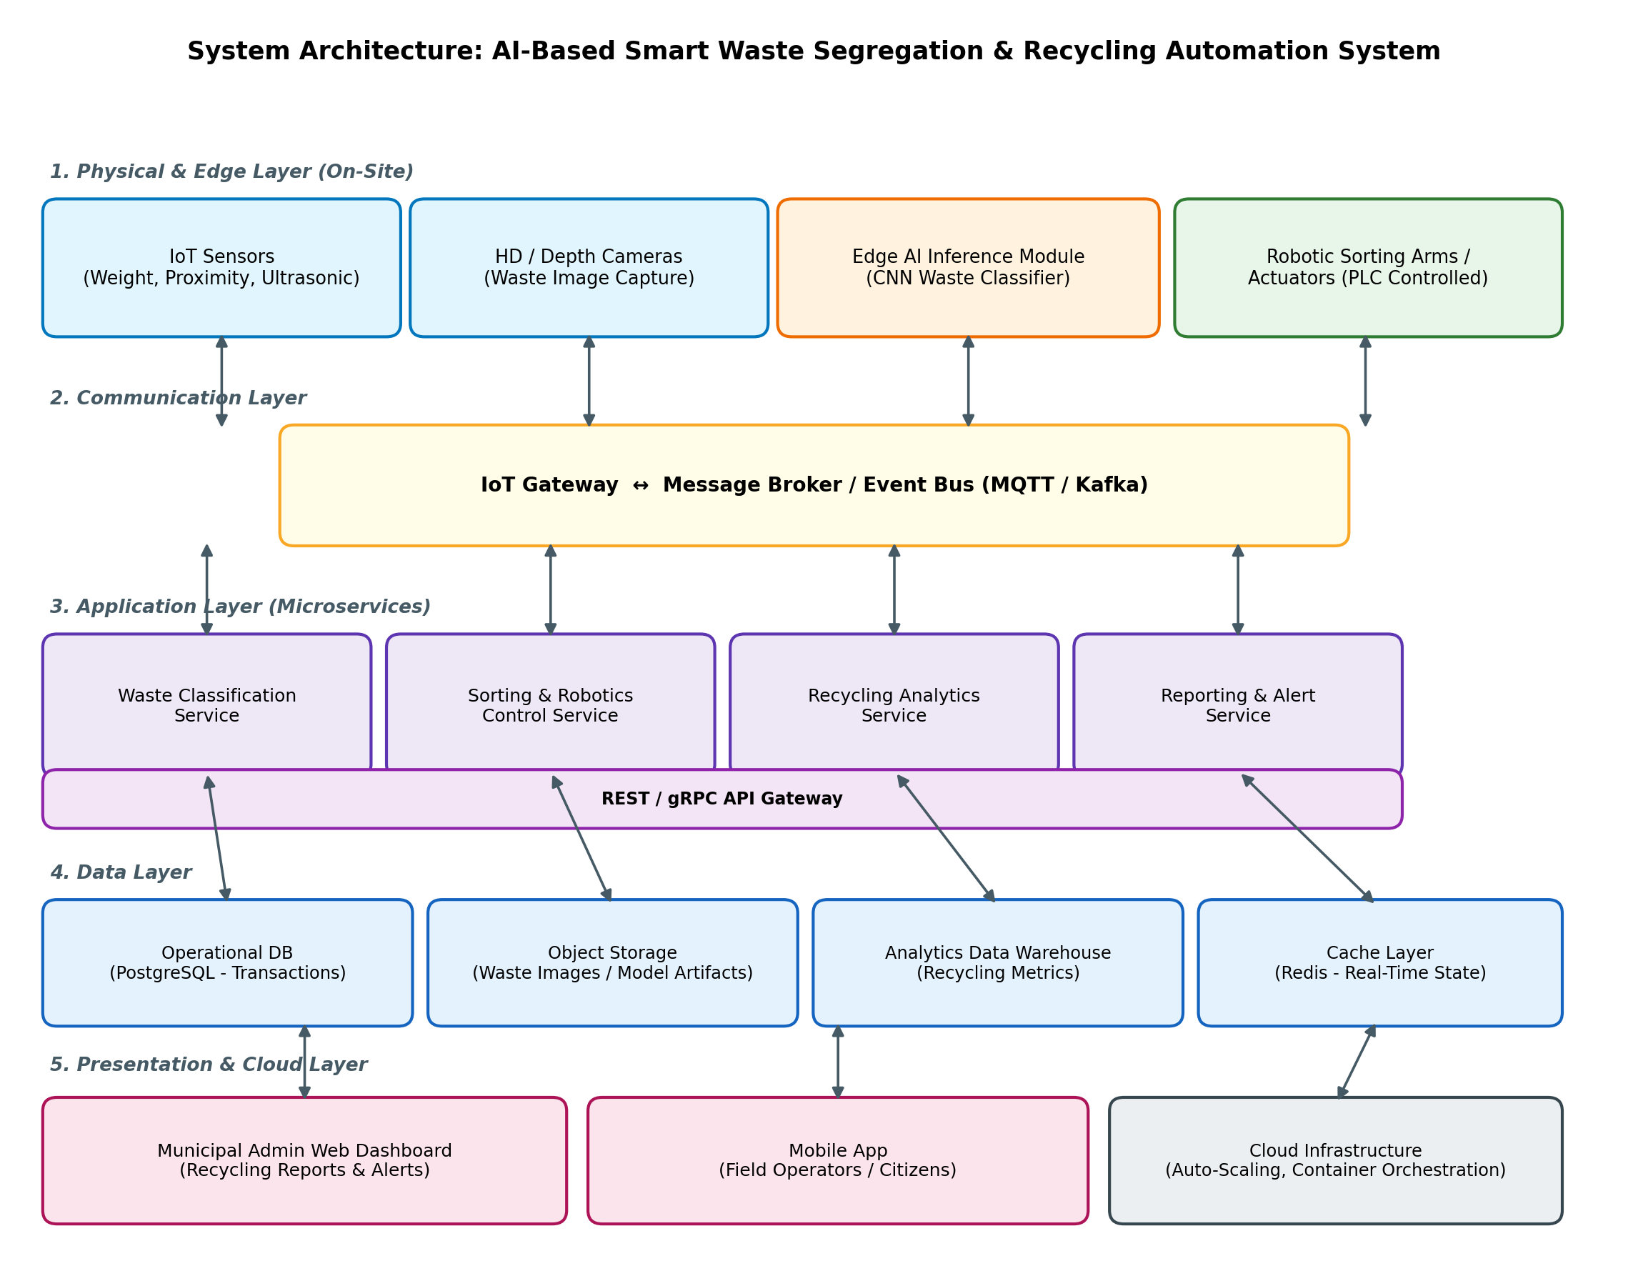
Fig. 1 — Layered / Event-Driven Microservices Architecture for the Smart Waste Segregation System

4. Components, Responsibilities, and Interactions

4.1 Component Responsibilities
Component | Responsibility
IoT Sensors & Cameras | Capture weight, proximity and high-resolution image/depth data for each waste item on the conveyor.
Edge AI Inference Module | Runs a CNN-based classifier locally at the facility to categorize waste with minimal latency.
Robotic Sorting Arms / Actuators | Physically divert each classified item into the correct bin based on control commands.
IoT Gateway / Message Broker | Aggregates device telemetry and publishes/subscribes classification and sort events (MQTT/Kafka) between edge devices and cloud services.
Waste Classification Service | Cloud-side service that validates/logs classification results and manages the AI model lifecycle.
Sorting & Robotics Control Service | Issues and tracks sort commands, monitors actuator health, and manages the manual-review queue.
Recycling Analytics Service | Aggregates processed-item data to compute recycling rate, contamination rate and throughput.
Reporting & Alert Service | Generates scheduled/on-demand reports and pushes real-time alerts (e.g., bin full, device offline).
Data Layer (Operational DB, Object Storage, Data Warehouse, Cache) | Persists transactional records, waste images/model artifacts, historical analytics, and low-latency runtime state respectively.
Admin Dashboard & Mobile App | Presentation layer for municipal staff and field operators to view reports, alerts, and facility status.

4.2 Interaction and Workflow
Components communicate primarily through asynchronous publish/subscribe messaging: edge devices publish sensor and classification events to the broker, and interested microservices subscribe to the relevant topics. Synchronous REST/gRPC calls via an API gateway are used only where an immediate response is required, such as the dashboard querying current facility status. This keeps the physical sorting path fast and decoupled from slower analytical and reporting workloads. The end-to-end workflow for a single waste item is shown below.

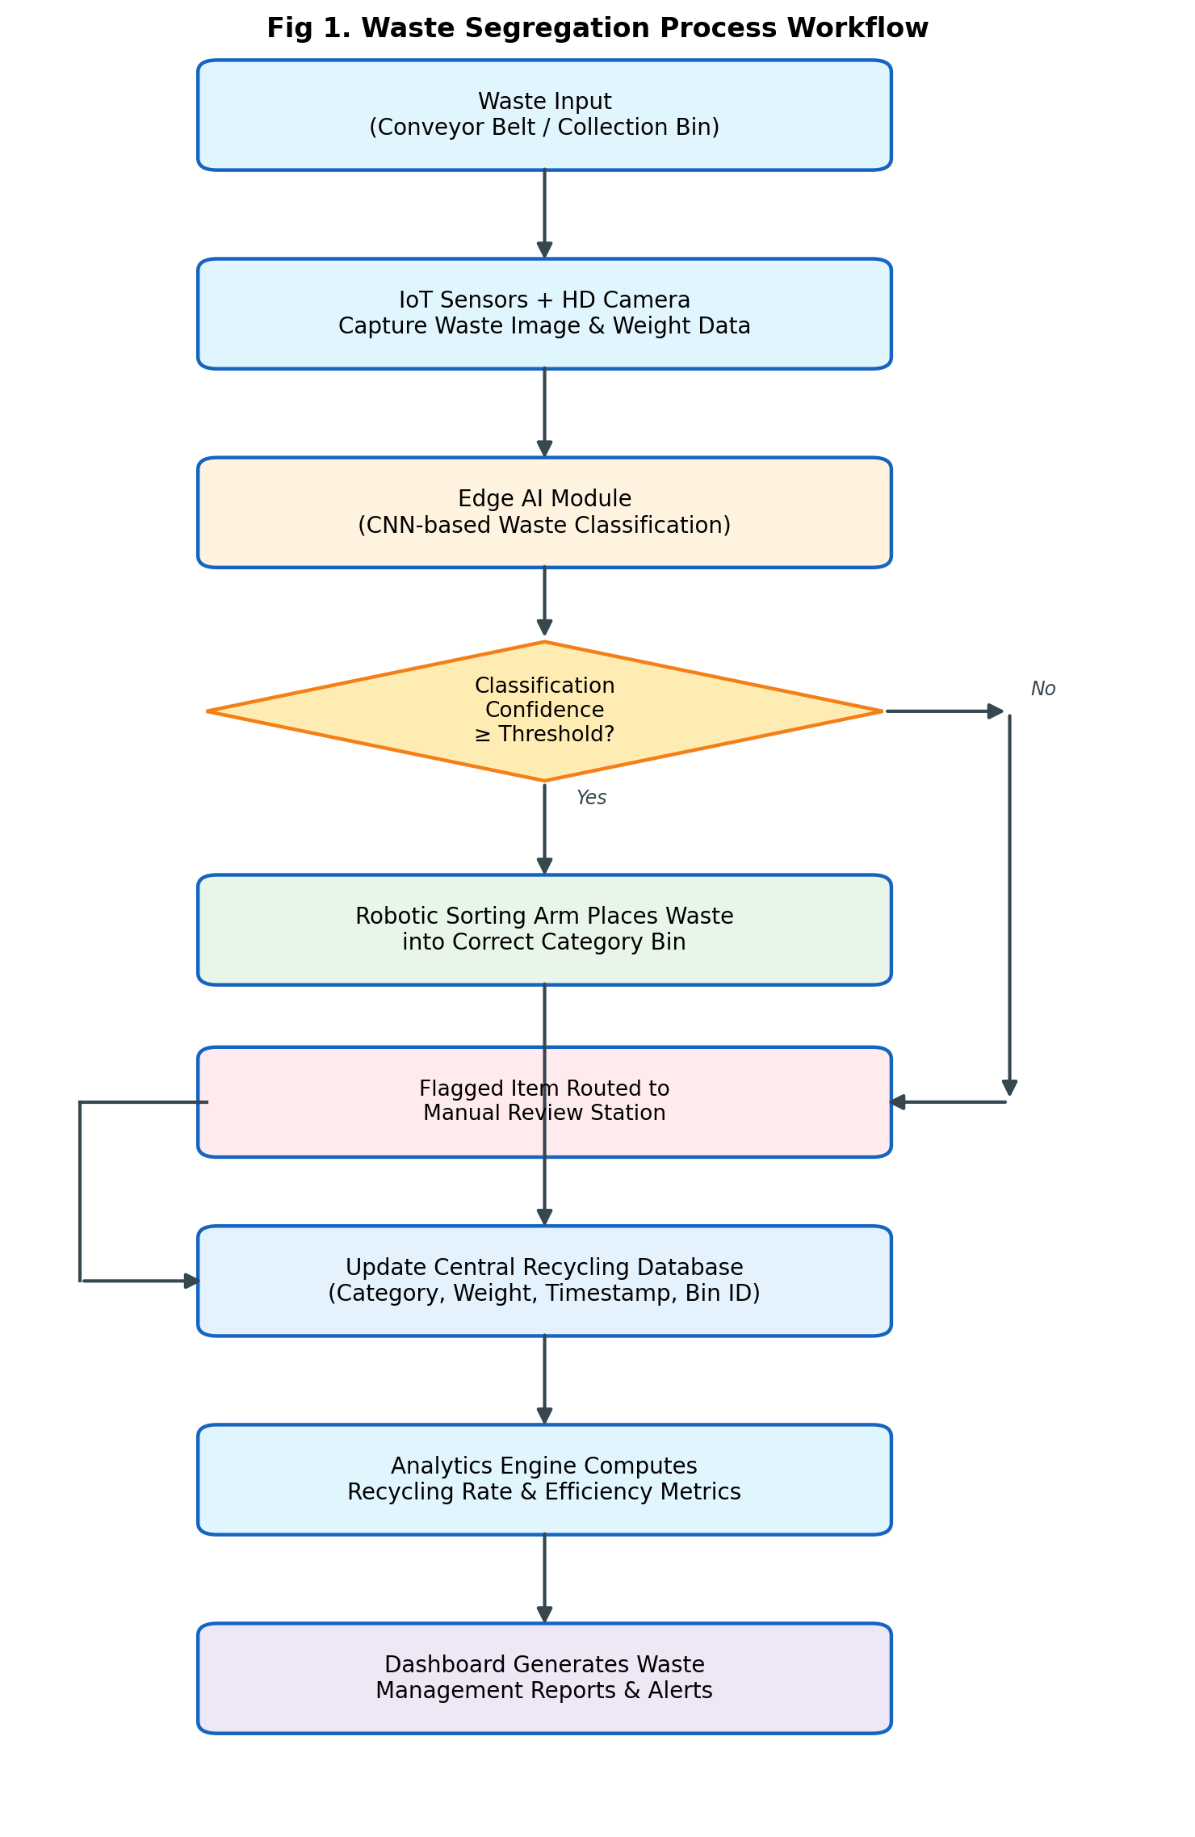
Fig. 2 — Waste Segregation Process Workflow (per item)

5. Discussion of Quality Attributes
The selected event-driven microservices-with-edge architecture directly addresses the six key quality attributes identified in Section 1.4:
Scalability: Each microservice and edge node scales independently; new facilities are onboarded by adding gateways to the event bus without re-architecting the system.
Security: Devices authenticate to the gateway using certificates/tokens, all broker and API traffic is TLS-encrypted, and dashboard access is role-based (admin vs. field operator).
Performance: Edge inference removes cloud round-trip latency from the sort-decision path, and the event bus buffers bursts of sensor traffic without blocking downstream services.
Reliability: The broker persists undelivered messages during transient network loss, and the manual-review path acts as a fallback for low-confidence classifications, preventing miscategorized recyclables.
Maintainability: Independently deployable services (e.g., the AI classifier) can be updated, retrained, or rolled back without redeploying the robotic control or analytics services.
Availability: Stateless microservices behind the API gateway can be replicated across containers/nodes, and the cache layer keeps recent state available even during a database failover.

5.1 Supporting Data: Sorting Accuracy Improvement
Automated AI-based sorting is expected to substantially outperform manual sorting on classification accuracy across all major waste categories, which is a key driver of the system's performance and reliability targets.
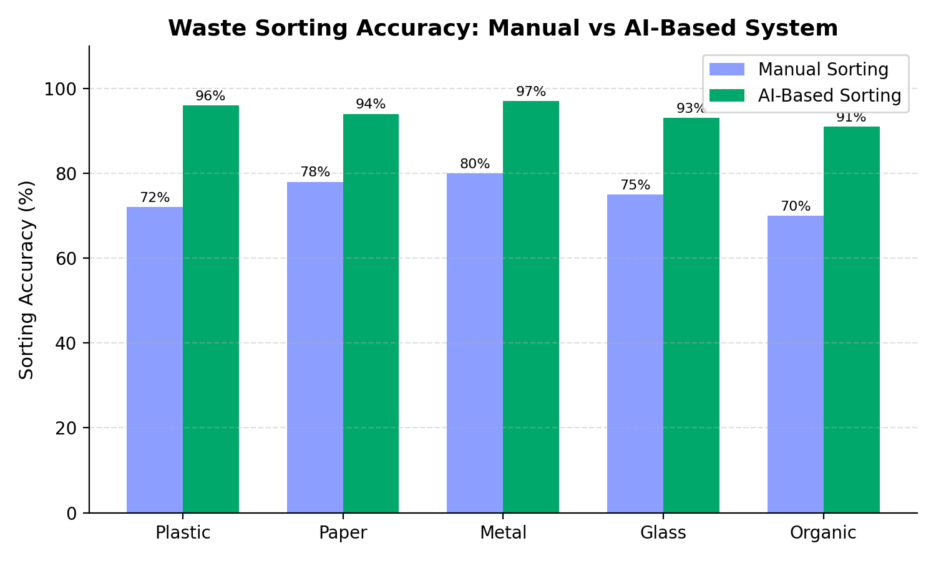
Fig. 3 — Projected Sorting Accuracy: Manual vs. AI-Based System, by Waste Category

5.2 Supporting Data: Waste Composition (Capacity Planning Input)
Understanding the typical composition of incoming municipal waste informs capacity planning and scalability decisions — for example, sizing the organic and plastic processing lines, which together account for the majority of throughput.
The pie chart shows the typical composition of municipal waste. Organic waste (40%) forms the largest portion, followed by Plastic (22%), Paper & Cardboard (17%), Metal (8%), Others (7%), and Glass (6%). This data helps plan recycling capacity, allocate resources, and improve the efficiency of the AI-based waste segregation system.
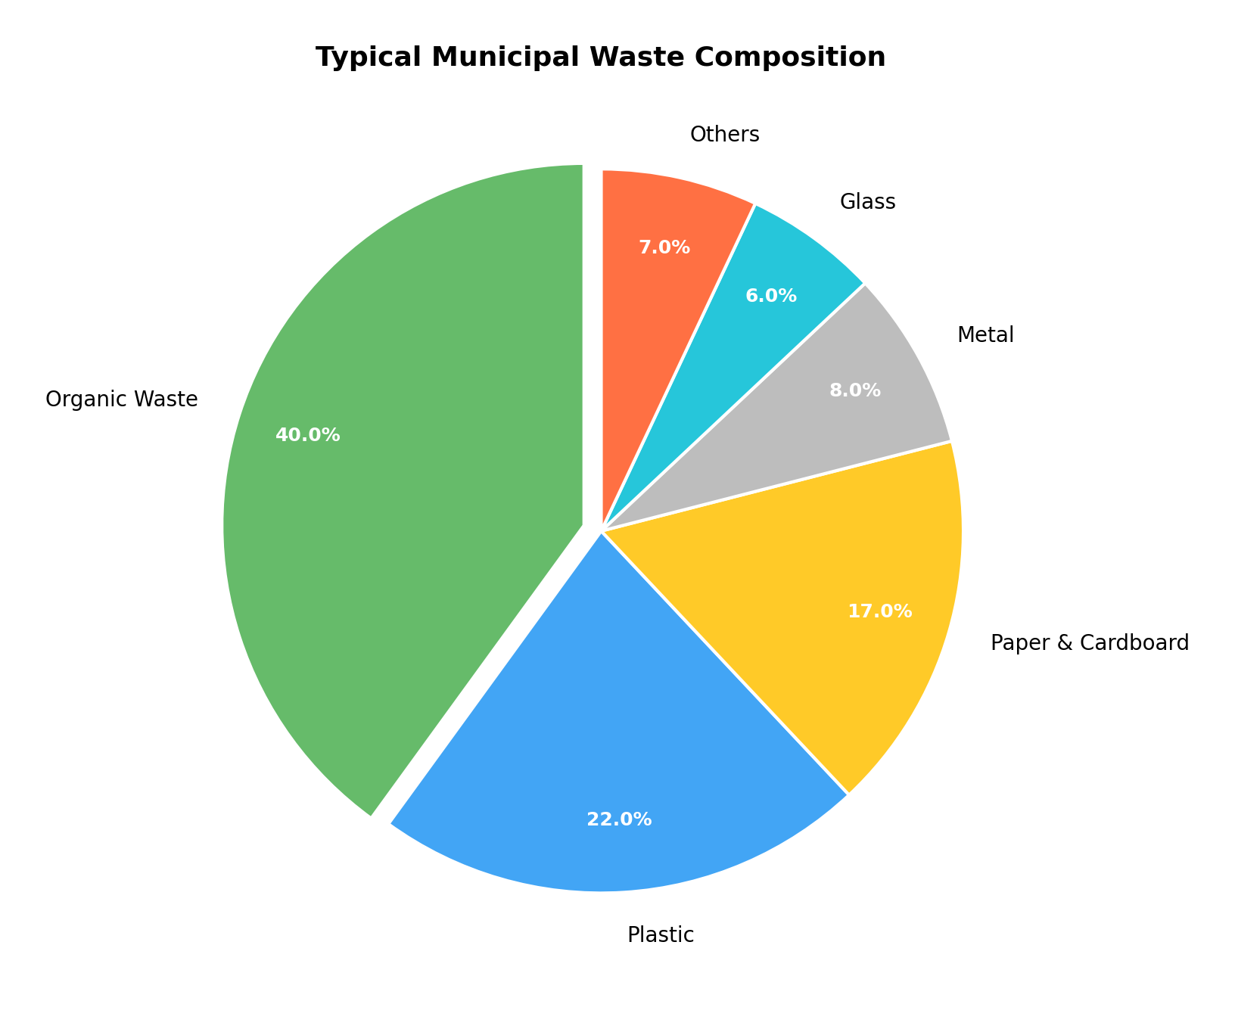
Fig. 4 — Typical Municipal Waste Composition Used for Capacity Planning

6. Justification of Architectural Decisions

6.1 Rationale
The core architectural decision — combining edge inference, an event bus, and microservices — is driven by the need to make a physical, real-time sorting decision while simultaneously supporting cloud-scale analytics and reporting. Placing the CNN classifier at the edge satisfies the hard real-time constraint of the conveyor, while the event bus and microservices satisfy the softer, higher-latency requirements of analytics, reporting, and multi-facility management. This separation of concerns allows each part of the system to be optimized for its own quality-attribute priorities rather than forcing a single design to satisfy all of them at once.

6.2 Trade-offs Considered
Trade-off | Decision and Rationale
Edge inference vs. cloud-only inference | Edge chosen for latency; accepts additional operational complexity of deploying and updating models on facility hardware, mitigated by an automated model-deployment pipeline.
Event-driven vs. synchronous REST-only | Event-driven chosen for decoupling and resilience to slow consumers; accepts eventual-consistency in the analytics/reporting views, which is acceptable since these are not real-time-critical.
Microservices vs. monolith | Microservices chosen for independent scalability and maintainability; accepts higher initial infrastructure/DevOps overhead, justified by the system's multi-facility growth goals.
Managed message broker vs. self-hosted | A managed broker is recommended to reduce operational burden, trading some cost for reduced maintenance risk.

6.3 Support for Future Enhancements and Long-Term Maintainability
- New waste categories (e.g., e-waste, hazardous items) can be added by retraining and redeploying only the Waste Classification Service.
- Additional facilities can be onboarded by connecting new edge gateways to the existing event bus, without modifying core services.
- New analytics (e.g., predictive bin-fill forecasting) can be added as new subscribers to existing event streams without touching the sorting pipeline.
- The API gateway provides a stable integration point for future third-party systems, such as municipal ERP or citizen-facing apps.
- Containerized microservices support future migration to Kubernetes-based auto-scaling as facility count grows.

6.4 Conclusion
The proposed event-driven microservices architecture with an edge-computing layer satisfies the functional requirements for AI-based waste classification and automated sorting while directly addressing the non-functional priorities of scalability, performance, reliability, availability, maintainability, and security. The design supports the stated objectives of increasing recycling rates, reducing landfill waste, and improving operational efficiency, and is structured to accommodate future growth in facility count, waste categories, and analytical capability.

